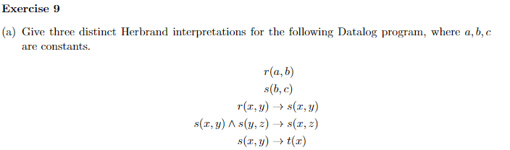

35. For P the Datalog programs from Exercise 9, determine v(P)

{ r(x, y) → s(x, y) | {x, y} ∈ {a,b,c} } ⋃

{ s(x, y) ⋀ s(y, z) → s(x, z) | {x, y, z} ∈ {a,b,c} } ⋃

{ s(x, y) → t(x) | {x, y} ∈ {a,b,c} }

v(P) = { rx,y → sx,y | {x, y} ∈ {a,b,c} } ⋃

{ sx,y ⋀ sy,z → sx,z | {x, y, z} ∈ {a,b,c} } ⋃

{ sx,y → tx | {x, y} ∈ {a,b,c} } ⋃

{ ra,b , sb,c }

36. Translate the following into formulas.

(a)

Socrates says:

(a) If I'm guilty, I must be punished.

G = If Socrates is guilty

P = Socrates must be punished

G → P

(b) I'm not guilty.

ㄱG

(c) Thus, I must not be punished.

ㄱP

(b)

C_P1 = Carlo won the competition

M_P2 = Mario came in second

S_P3 = Sergio came third

(a) “If Carlo won the competition, then either Mario came second or Sergio came third”

(C_P1) → (M_P2) ⋁ (S_P3)

(b) ㄱ(S_P3)

(c) ∴ ㄱM_P2 → ㄱC_P1

37.

Show that (G → P) ^ ㄱG ^ P is satisfiable

|  |  |  |  |  |  |
| --- | --- | --- | --- | --- | --- |
| G | P | G → P | ㄱG | (G → P) ^ ㄱG | (G → P) ^ ㄱG ^ P |
| 0 | 0 | 1 | 1 | 1 | 0 |
| **0** | **1** | **1** | **1** | **1** | **1** |
| 1 | 0 | 0 | 0 | 0 | 0 |
| 1 | 1 | 1 | 0 | 0 | 0 |

There exists a model A where A(G)=0, A(P)=1